Lab Report

Your Information
Your Name: Joshua Zimmerman-Gibson
Assignment Title: SQL Database Creation and Querying

Screenshots
- Verify the data was loaded correctly by performing a count of all the rows from each table
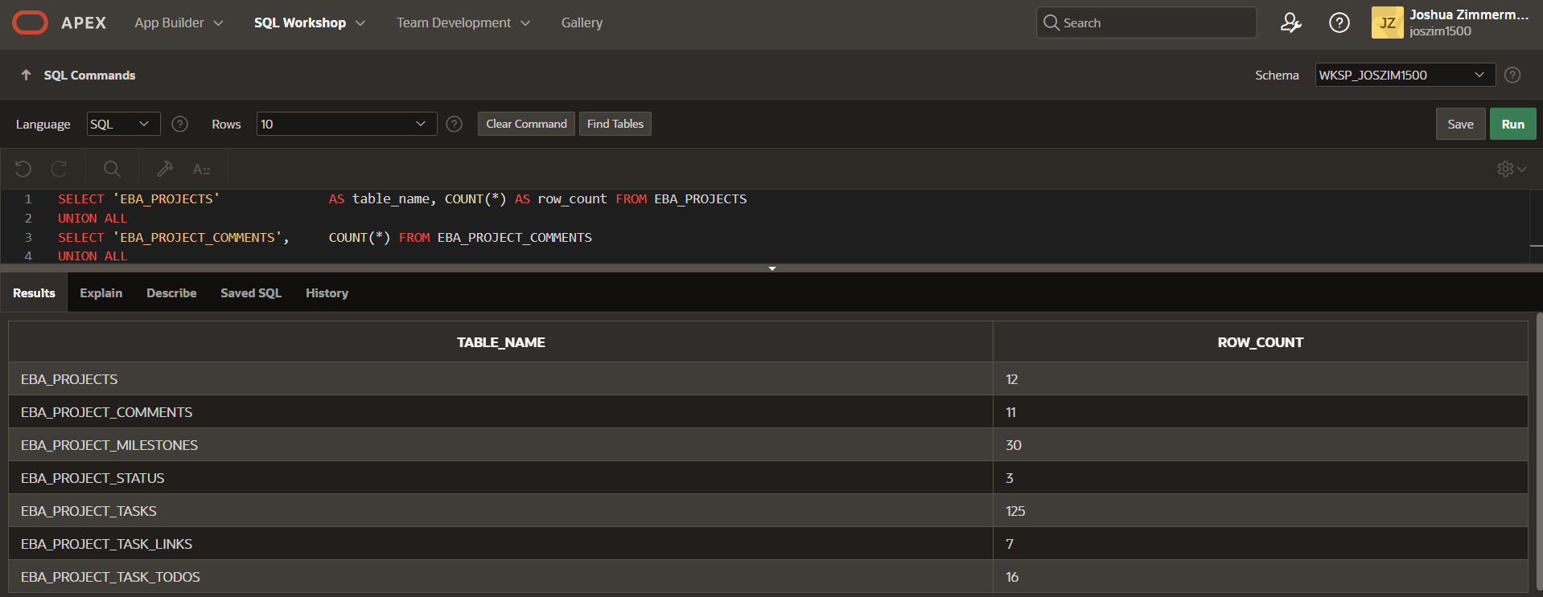
- Display every comment made by BERNIE (screenshot).
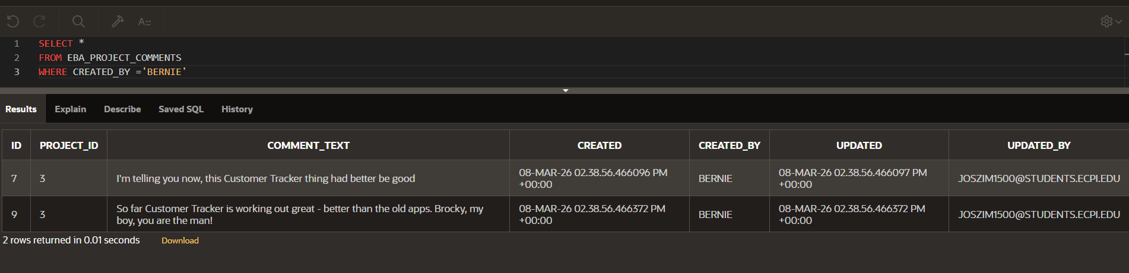
- Create a list of every task assignee without duplicates (screenshot).
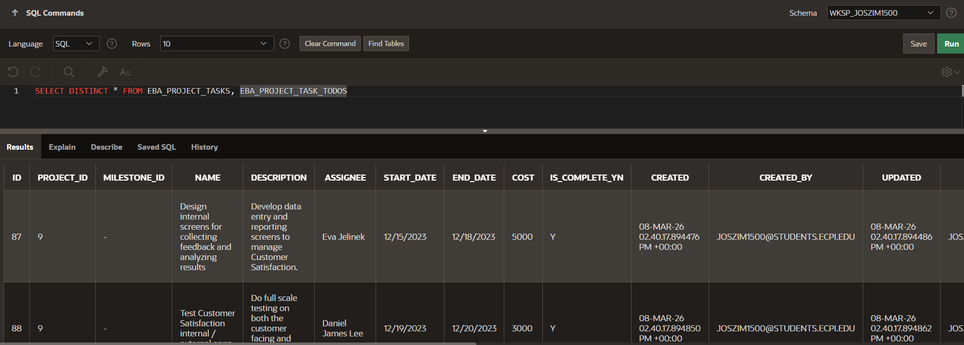
- List every project lead and the number of projects they are responsible for (screenshot).
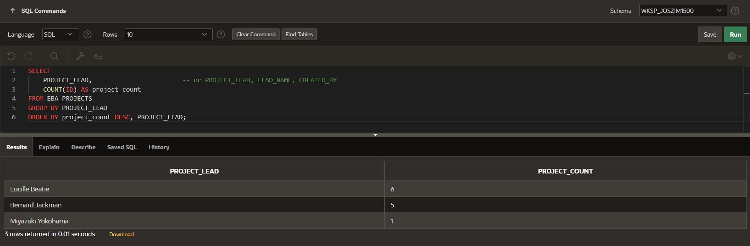
- Count the number of task todos per task. Order the results starting from the least amount of todos (screenshot).
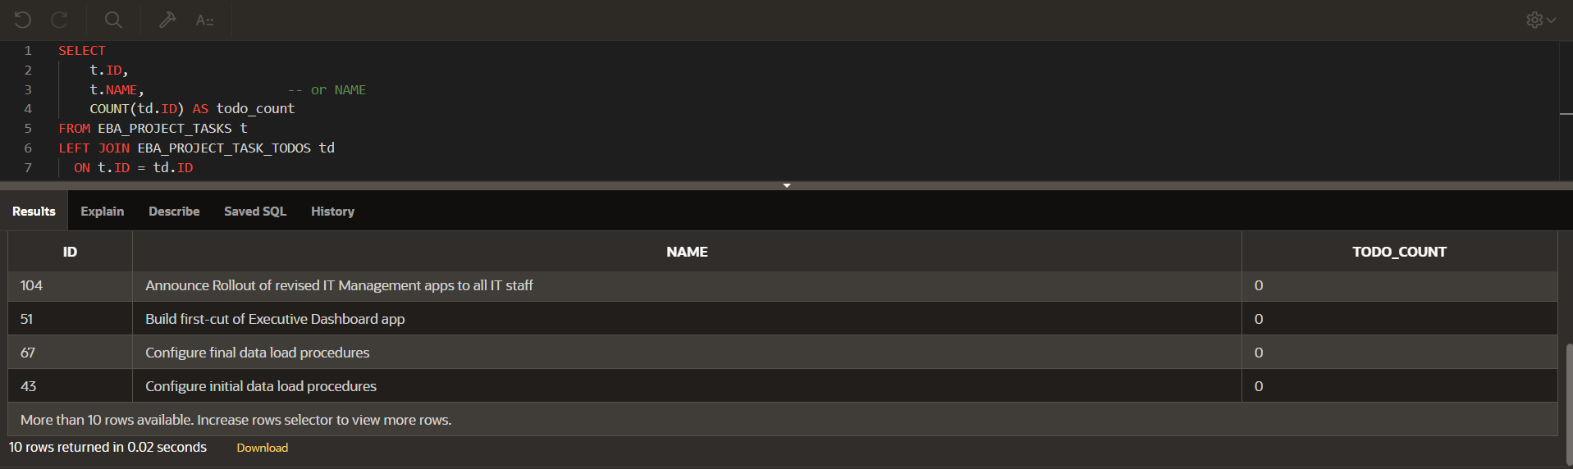
- Display the name, description, budget, and status description for every uncompleted project. Order the results by highest to lowest budget (screenshot).
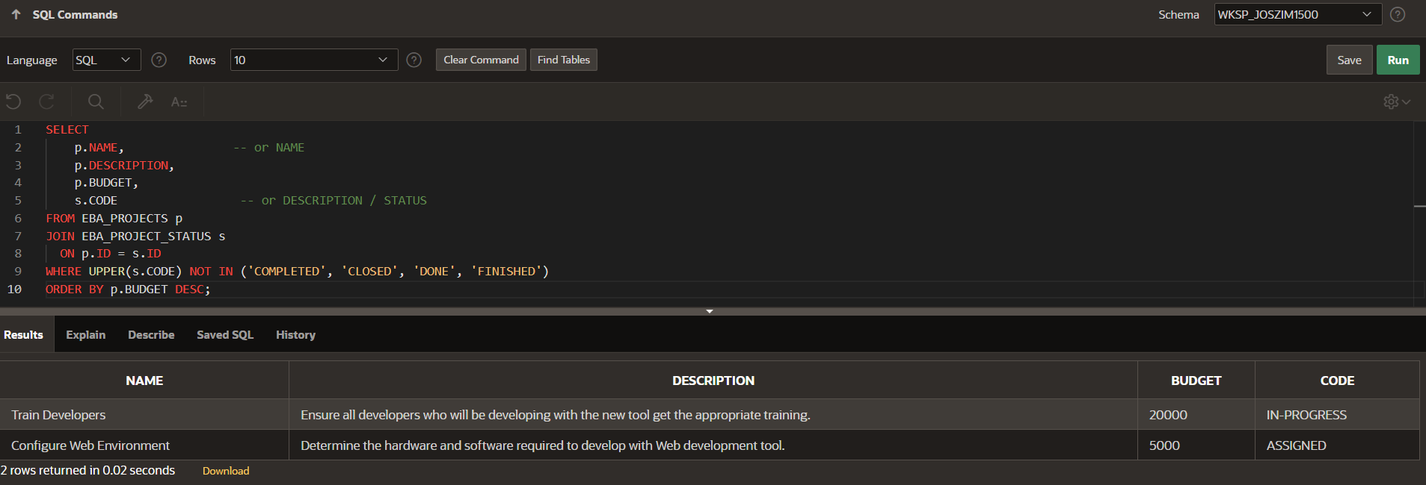
- Find the average number of milestones per project, the average number of tasks per milestone, and the average number of tasks per project (screenshot).
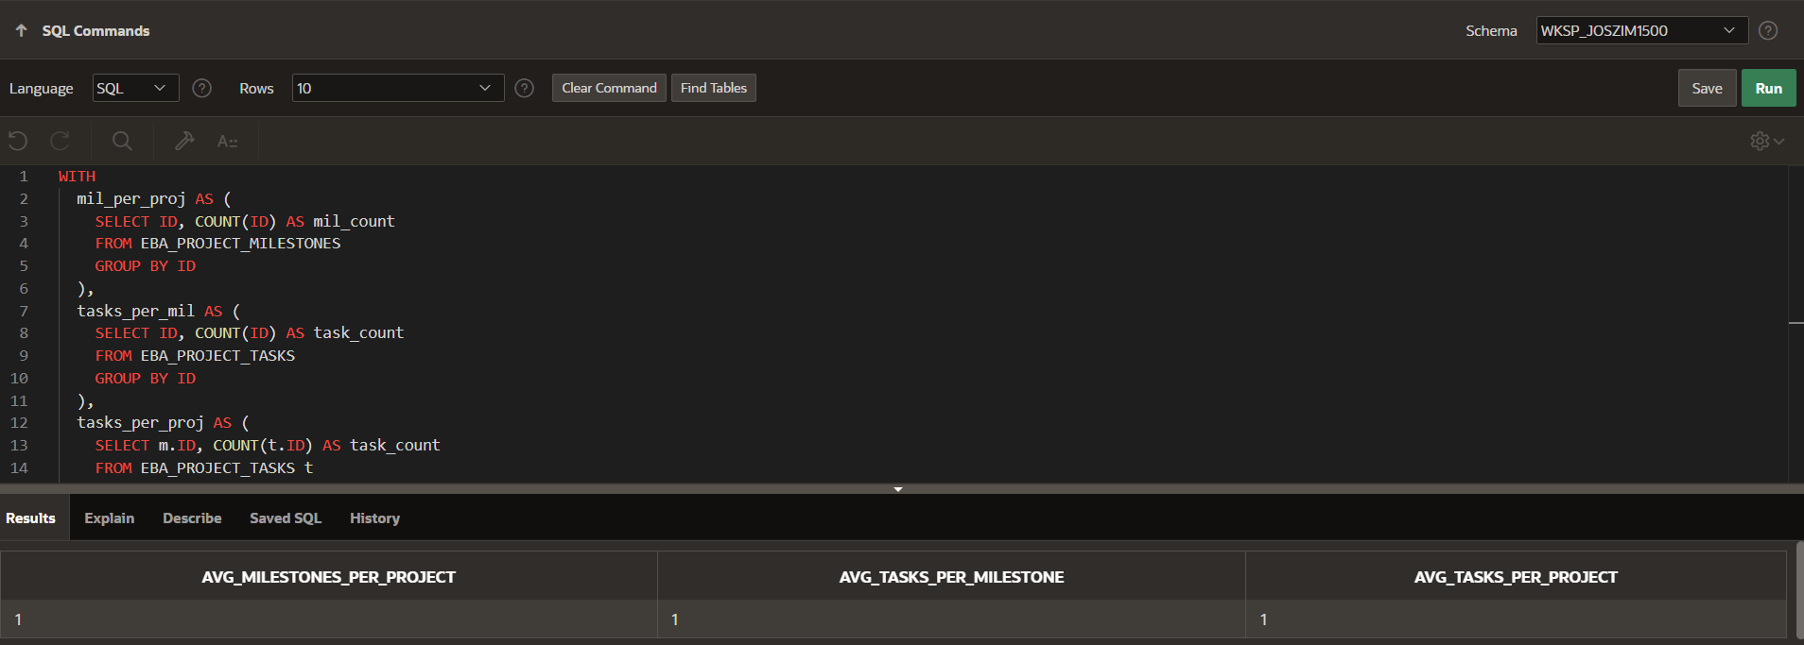
- Show the project name, milestone name, task count per milestone, and total costs to complete the tasks assigned to the milestone. Exclude results with a total cost of less than $1000 (screenshot).
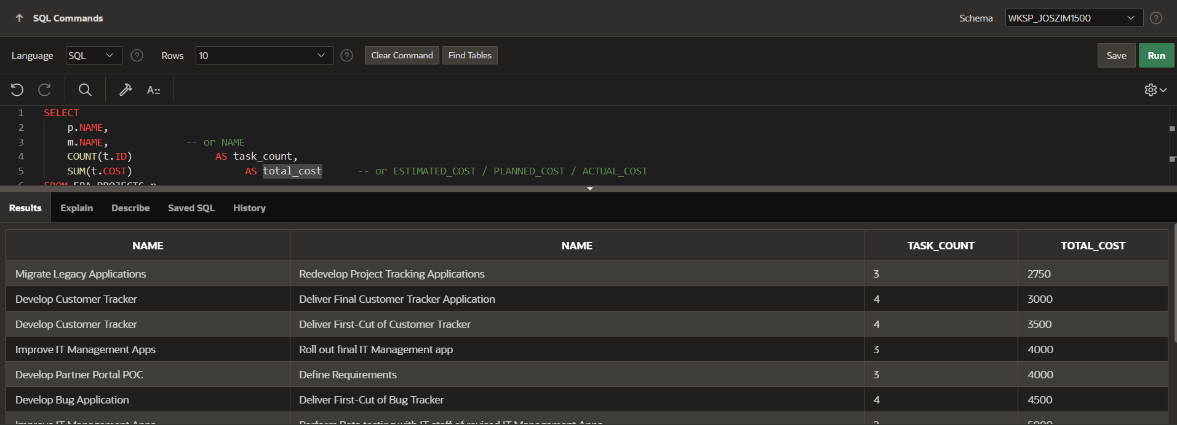
- Display the project name, project lead, budget, and cost of every completed project that went over budget (screenshot).
SELECT
S.CODE,
p.PROJECT_LEAD,
p.BUDGET,
t.COST, -- or TOTAL_COST / ACTUAL_COST
(t.COST - p.BUDGET) AS over_budget_amount
FROM EBA_PROJECTS p, EBA_PROJECT_TASKS t, EBA_PROJECT_STATUS s
WHERE UPPER(s.CODE) IN ('COMPLETED', 'CLOSED', 'DONE', 'FINISHED')
AND t.COST > p.BUDGET
ORDER BY over_budget_amount;
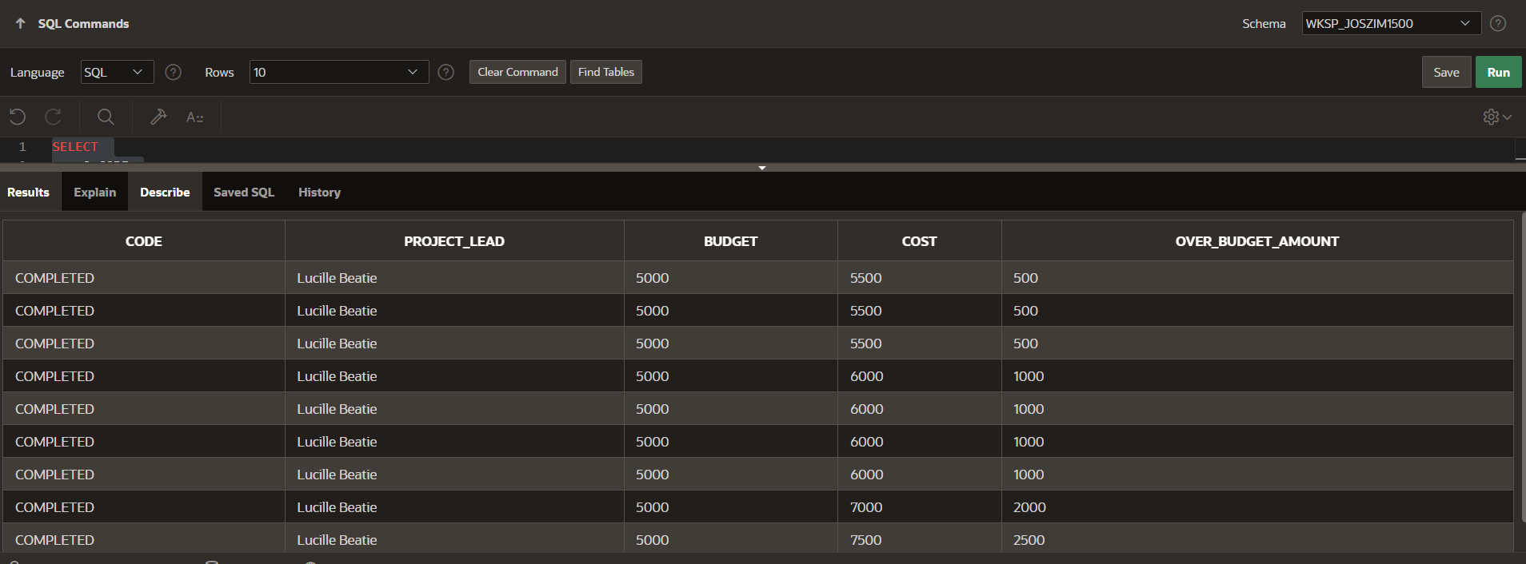
- Display the count of completed tasks, late tasks, and incomplete tasks for every completed project (screenshot).
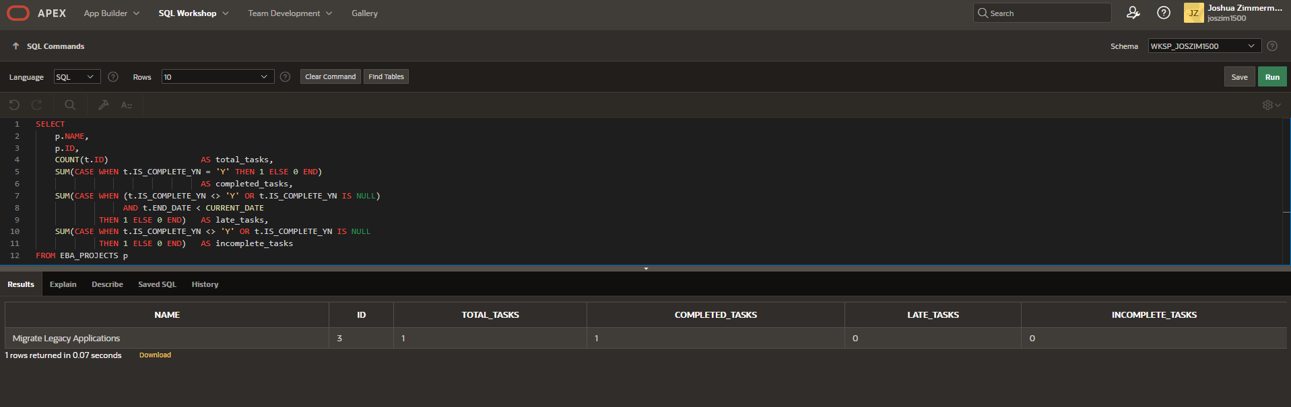

Questions
- A few common aggregate functions not covered in this exercise are: MIN(), MAX(), STDDEV(), and VARIANCE(). Given the dataset used in this exercise, give an example of useful analytical information we could obtain with the use of each function.
MIN() – Minimum Value
Example insight:
- Find the minimum project budget to identify the smallest-scale project in the system.
MAX() – Maximum Value
Example insight:
- Find the maximum task cost to identify the most expensive task in the entire database.
STDDEV() – Standard Deviation
Example insight:
- Calculate the standard deviation of project budgets to see how much variation exists across all projects.
VARIANCE() – Statistical Variance
Example insight:
- Calculate the variance of task durations or costs to understand how widely spread task values are.

- There are four main types of joins: LEFT, RIGHT, INNER, and FULL. How does the result set change based on the specific type of join used?

INNER JOIN
- Returns only the rows where matching values exist in both tables.
- Excludes any unmatched rows.
- Use when you only care about data that appears in both datasets.
LEFT JOIN (Left Outer Join)
- Returns all rows from the left table, plus matching rows from the right table.
- Non-matching rows from the right table become NULL.
- Useful for: “Show all projects, even if they have no tasks.”
RIGHT JOIN (Right Outer Join)
- Returns all rows from the right table, plus matching rows from the left table.
- Non-matching rows from the left table become NULL.
- Useful when the right table contains the dataset you want fully represented.
FULL JOIN (Full Outer Join)
- Returns all rows from both tables, including:
  - matching rows
  - non-matching rows from the left table
  - non-matching rows from the right table
- Gaps in either table become NULL.
- Useful for comprehensive comparisons or data reconciliation.
- Null values can cause anomalies in statistical calculations. What are some techniques or methods that can be used to handle null values in a dataset?
1. Filtering Out Nulls
- Remove rows containing nulls when they are not essential.
2. Using COALESCE() or NVL()
- Replace null values with a default (e.g., 0, “Unknown”, etc.).
3. Imputation
- Substitute missing values using:
  - mean
  - median
  - mode
  - a domain-specific replacement value
- Common in statistical and machine-learning preprocessing.
4. Conditional Aggregation
- Prevent nulls from skewing aggregate functions.
5. Using NULL-aware operators
- For example, COUNT(column) ignores nulls, while COUNT(*) counts all rows.
- Choosing the correct version prevents misinterpretation of results.

